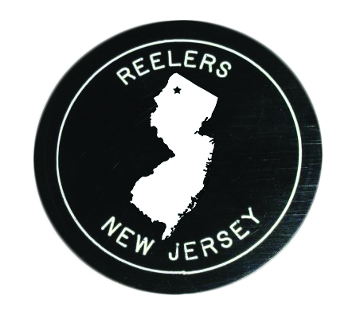  Info: Karen Condon  201-841-7523  kmc07834@yahoo.com  reelers.nnjsda.org |  | REELERS  Plus Club with Rounds  Ironia School, 303 Dover-Chester Road (Route 513)  Randolph, NJ 07869  1st and 3rd Fridays  7:30 – Early Rounds 8:00 – Plus/Rounds
For Mainstream class info, contact Karen Condon: see above
For info on round dance classes at various levels,
call or text Mary Pickett: 908-419-3605
Bring your friends to our three community (intro) dances:
Tuesday 9/9/25; Tuesday 9/16/25; Friday 5/29/26
 | Cuer: Mary Pickett unless noted
2025-26 | Caller |  | Theme
09/05 | Mark Franks (NJ) |  | Welcome Back (club colors)
09/19 | Clay Goss (DE) |  | Fall Ice Cream Festival
10/03 | Howard Richman (NJ) |  | Movie and Show Tunes
10/17 | Karin Rabe/Greg Moore (NJ) |  | Around the World
11/07 | No Dance
11/21 | Ted Lizotte (NH) |  | Give Thanks(food donation)
12/05 | Doug Kauffman (NJ) |  | Books for Kids (new books)
12/19 | Paul Ingis (NJ) |  | Holiday Dance
01/16 | Sandy Corey (NY) |  | Denim Hoedown
02/06 | Dave Black (PA) |  | Souper Bowl (canned soup)
02/20 | Jenn Engimann (PA) |  | Bring on the Pies
03/06 | Dan Koft (PA) – Kathy cuing |  | Chocoholics’ Delight
03/20¹ | Dane Bragg (PA) |  | Welcome, Students
04/17² | Clay Goss (DE) |  | Treasurers’ Break
05/01 | Ed Foote (PA) |  | Sounds of the 60s and 70s
05/15 | Mark Franks (NJ) |  | Ice Cream Social
06/05 | Howard Richman (NJ) |  | Beach Bash
¹Student Mainstream, no rounds ²Club treasurers free

Event desc - Plus Square Dance alternating with Rounds

Reelers Plus Club with Rounds

